Program No.01:

**CODE:**

<html>

    <head>

        <title>First web page</title>

    </head>

<body>

    <h1>HELLO! My name is </h1>

    <h1><a href="https://www.linkedin.com/in/not-darshil-kumar/">Darshil</a></h1>

    <h2>I am a second year student</h2>

    <p>This is first program of this lab and this program includes hyperlink,head,title,body,paragraph tags.</p>

</body>

</html>

**OUTPUT:**

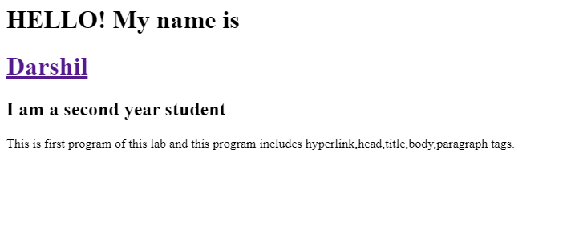

Program No.02:

**CODE:**

<html>

    <head>

        <title>second web page</title>

    </head>

<body>

    <h2>HEllO! My name is <a href="https://www.linkedin.com/in/not-darshil-kumar/">Darshil</a></h2>

    <h2></h2>

    <h2>I am a second year student</h2>

    <p>This is second program of this lab and this program includes bold,italic,underline,subscript,supercript and images tags.</p>

    <p>This is for <b>Bold</b> Tag</p>

    <p>This is for <i>Italic</i> Tag</p>

    <p>This is for <u>Underline</u> Tag</p>

    <p>This is for <sub>Sub Script</sub> Tag</p>

    <p>This is for <sup>Super Script</sup> Tag</p>

    <img src="\images\bg.png" alt="Background" width="1530" height="1200">

</body>

</html>

**OUTPUT:**

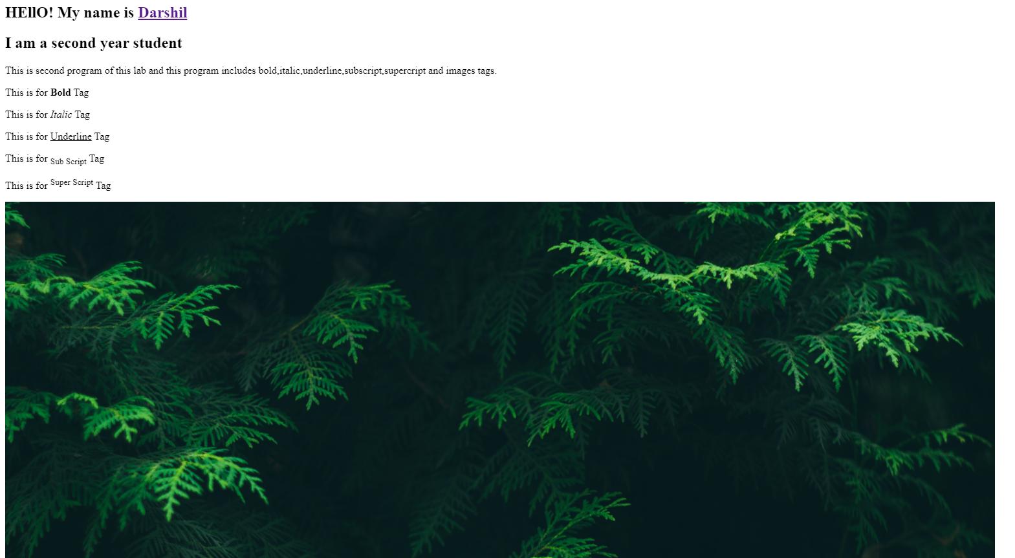

Program No.03:

**CODE:**

    <html>

        <head>

            <title>third web page</title>

        </head>

    <body>

        <h2>Welcome!</h2>

        </p>This is Web designing lab and this is program 3 </p>

        </p>This is Web designing lab and this is program 3 </p>

        <hrx>

        <hr>

        <h2>HTML</h2>

        <p>The HyperText Markup Language or HTML is the standard markup language for documents designed to be displayed in a web browser. It defines the meaning and structure of web content. It is often assisted by technologies such as Cascading Style Sheets and scripting languages such as JavaScript.</p>

        </p><a href="https://en.wikipedia.org/wiki/HTML">More</a></p>

        <hr>

        <h2>CSS</h2>

        <p>Cascading Style Sheets is a style sheet language used for describing the presentation of a document written in a markup language such as HTML or XML. CSS is a cornerstone technology of the World Wide Web, alongside HTML and JavaScript.</p>

        </p><a href="https://en.wikipedia.org/wiki/CSS">More</a></p>

        <hr>

        <h2>JavaScript</h2>

        <p>The HyperText Markup Language or HTML is the standard markup language for documents designed to be displayed in a web browser. It defines the meaning and structure of web content. It is often assisted by technologies such as Cascading Style Sheets and scripting languages such as JavaScript.</p>

        </p><a href="https://en.wikipedia.org/wiki/HTML">More</a></p>

        <hr>

    </body>

    </html>

**OUTPUT:**

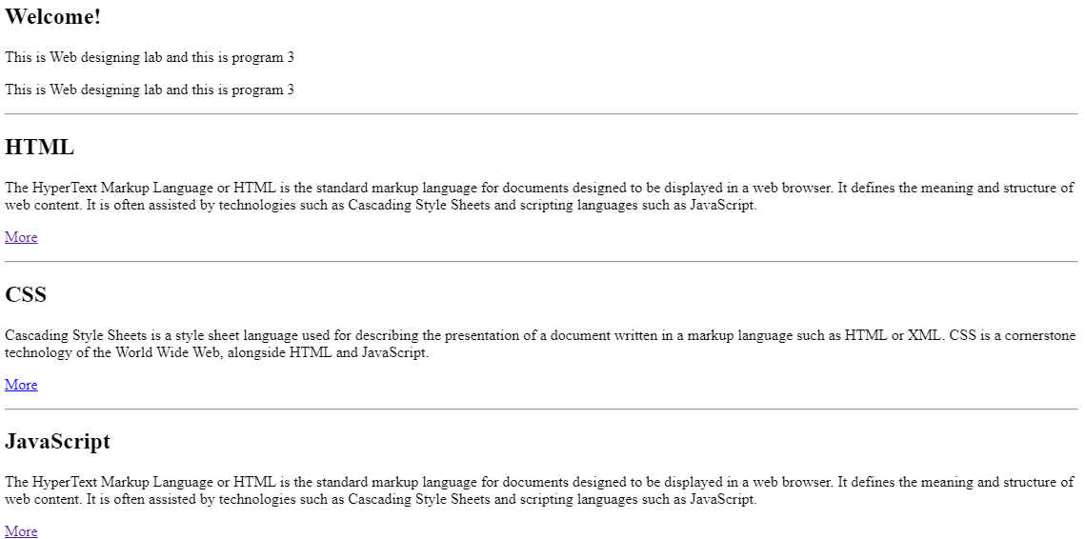

**Program No.04:** create a webpage in html using html tags for table, rows, table data and table headings of any 3 students

**CODE:**

<!DOCTYPE html>

<html lang="en">

<head>

    <meta charset="UTF-8">

    <meta name="viewport" content="width=device-width, initial-scale=1.0">

    <title>Document</title>

</head>

<body>

    <table>

        <tr>

            <th>Name</th>

            <th>Contact</th>

            <th>Roll No</th>

        </tr>

        <tr>

            <td>Darshil Kumar</td>

            <td>7678163042</td>

            <td>2202900100071</td>

        </tr>

        <tr>

            <td>Devansh Singh</td>

            <td>9999988888</td>

            <td>2202900100071</td>

        </tr>

        <tr>

            <td>Ishmeet Singh Sodhi</td>

            <td> 1111122222</td>

            <td>2202900100075</td>

        </tr>

    </table>

</body>

</html>

**OUTPUT:**

